Simulation of IOT Based Fire Alert System

Md. Moniruzzaman Shanto Farzana Akhi Shimanto Krishna Chakroborty

2018-1-60-075 2016-2-60-142 2017-2-68-001

Department of CSE Department of CSE Department of CSE

East West University East West University East West University

Dhaka, Bangladesh Dhaka, Bangladesh Dhaka, Bangladesh

ms.shanto1234@gmail.com akhi123@ieee.org chakrobortyshimanto@gmail.com

***Abstract*—** **Fire alarm system plays an important role in maintaining and monitoring the safety of all kind environments and situation. Nonetheless, the ease of use of many existing fire alert system is notable yet could be produced with significant expense likewise it needs customary preventive upkeep to be done to ensure the framework works well. In the meantime, when the upkeep is being done to the current framework it could raise the expense of utilizing the framework the fundamental goal of this venture is to make an aflame control system with minimal expense. This task talks about the powerful technique to utilize the microcontroller (Arduino) to control different parts to give a modest alarm, firefighting which can be utilized for all the wider vision. C language is utilized for programming and Proteus is utilized for the re-enactment and equipment. From the task done, the system is expected to give a speedy reaction to the current circumstance. the framework can recognize warmth and fire detected by the indicators. When the sensors structure each level set off independently, the primary ringer works, and it shows in the control board LCD show alert.**

Keywords— Arduino, temperature Sensor, LCD Display, Fire sensor, buzzer

1. Introduction

The Fire Alert System is vital for the structures, uniquely, the high one, to shield human and his things from being singed, and that by giving an alert to show that there is a fire in the structure, so everybody in the structure will fare thee well to himself and escape constructing promptly, and furthermore can call the firemen to come and annihilate the fire, and that in case there isn't an arrangement of battling (just alert system). Be that as it may, in case there is a battling framework, it will complete the fire in a couple minutes.[1] Fire alarm system distinguishes the fire to give a caution naturally or physically. Alarm gadget is an incorporated electronic gadget comprising of a few gadgets touchy to various fire yields, control gadgets, helper organizations, and others.

**Objectives:**

Our objective is to implement a system which will detect fire using fire sensor and the system will automatically display fire detection alert on the LCD monitor. Moreover, the system will also turn on necessary devices to alert the whole area. User can monitor this system by using his smart phone or computer. The system will show current state wither fire is detected or not and user will be notified if fire is detected in the house.

# Research Methodology

In a manner to accomplish above targets, this proposition used to be carried out as beneath:

1) To make a reproduction and equipment to accomplish a task objective

2) The Arduino is utilized as hart of this alarm framework to control the whole tasks included

3) The alarm framework joins the warmth and fire locators that are associated in corresponding to find and distinguish the spot that is in fire

4) The LCD show the current circumstance of the sensors

**III. The purpose of using alarm devices:**

1)To identify the fire and its area.

2) To caution the tenants of the structure in case of fire, to empower them to scape.

3) To battle the fire in its beginning phases.

4) To illuminate the closest fire station.

5) Likewise, to work some programmed smothering frameworks or a portion of the administrations for fire security purposes through a framework board

# Working Procedure

Required Software:

1. Proteus 8 professional: Proteus 8 professional will be used to show the simulation of the connections between the microcontroller and the necessary sensors.
2. Cisco Packet Tracer: To show the network simulation between the user and the system Cisco Packet Tracer will be used. If the system detects any fire, the system will send fire alert from the home and by using the network the alert will be visible into user’s smart device. Use can also view the current state using this network.

Required Components:

1. Microcontroller
2. Arduino UNO
3. Fire sensor or Flame sensor
4. Temperature sensor
5. Small Breadboard
6. Connecting Wire
7. Arduino1.6.1 software
8. Liquid Crystal Display (LCD)
9. Buzzer
10. fire sprinkler
11. Specker
12. Siren
13. Home gateway
14. **Microcontroller:**

Number of microcontrollers from various organizations is accessible on the lookout. In this venture ATmega328P is utilized, figure (4.3.1A-B). The ATmega328 is a solitary chip microcontroller made by Atmel in the megaAVR family. It has an adjusted.

1. **Arduino Uno:**

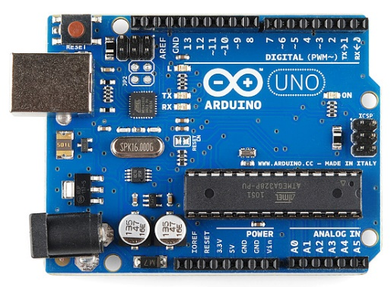

Figure: Arduino Uno

**Arduino Uno** is a microcontroller board based on the ATmega328P. It has 14 digital input/output pins (of which 6 can be used as PWM outputs), 6 analog inputs, a 16 MHz quartz crystal, a USB connection, a power jack, an ICSP header and a reset button. It contains everything needed to support the microcontroller; simply connect it to a computer with a USB cable or power it with an AC-to-DC adapter or battery to get started.

Analog input:

Six analog input pins are on the Arduino Uno board. A0 to A5 are the names of these analog inputs. We can complete the procedure by using analog inputs. Within the operational range of 0 to 5 V, analog inputs can be used. It's a continuous time signal. These analog time signals are suitable for a variety of applications. Non-discrete temporal signals are also known as this.Inputs such as voltage, current, and others are classified as analog or digital signals, which are evaluated by examining the attributes of the time signal. The Arduino Uno can be utilized in a variety of applications that only accept analog inputs rather than digital ones. Analog input pins or ports can be used for these applications.

Digital input:

Digital inputs can be defined as a non-continuous time signal when using discrete input pulses. It can be expressed as a series of 0s and 1s. These digital inputs can be turned on or off it's possible D0 through D11 are the 12 digital input pins on the Arduino Uno. I'm ready to get started. This program can primarily use 12 inputs. The digital inputs work where discrete input pulses can be triggered and sent to the ports. These ports receive input and can be used for both input and output. Only digital pins are available in digital inputs.

Power jack cable/USB port:

This Arduino Uno can be connected to other electronic devices such as a computer via a USB connection or a power jack cable, allowing us to upload Arduino programs for many uses. The application can be initialized or changed using Arduino software tools at first. Then, using a USB cable or a power jack connector, these programs can be transferred to an Arduino microcontroller board.

Power supply:

These power sources provide the Arduino uno an active form that can accept a wide range of power. In Arduino Uno, there is an additional power supply source. The Arduino Uno has a power supply port on the corner. There are two ways to use the power supply port. When the power supply voltage range exceeds, one option is to connect with an external power supply, or another option is to connect a dc power source through input pins. The Arduino uno is then ruined. As a result, only a specific range of power supply should be provided to the Arduino uno.

Power Supply:

The Arduino uno board or an external power supply can be used to provide electricity. It has to be 5 volts. There are three pins on the IR Proximity Sensor board. VCC, GND, and Output are the three. VCC and GND are used to connect to a power source. If we utilize the Arduino uno board for power, VCC is connected to the Arduino uno board's VCC, and ground is also connected to the Arduino uno board's VCC.

Output:

If any obstacles come close to the IR sensor, an output from the IR Proximity sensor is generated, and this output is used as an Arduino uno input. Which is the 3rd pin number.

Input:

An Arduino uno input connection is used to control the relay module. Pin number 8 is associated to this. This is a digital pin that functions as a switch.

1. **Fire Sensor:**

A flame detector is a sensor designed to detect and respond to the presence of a flame or fire. Responses to a detected flame depend on the installation, but can include sounding an alarm, deactivating a fuel line (such as a propane or a natural gas line), and activating a fire suppression system. This Fire Sensor can be utilized to identify fire source or other light wellsprings of the frequency in the scope of 760nm - 1100 nm. It depends on the YG1006 sensor which is a fast a lot touchy NPN silicon phototransistor. Because of its dark epoxy, the sensor is delicate to infrared radiation.

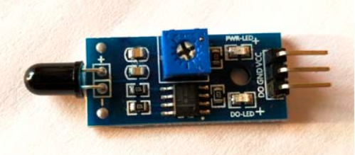

**Figure 1:** flame sensor

1. **Temperature sensor**

Various temperature sensors are accessible on the lookout. In this task the LM35 temperature sensor is utilized The LM35 series are accuracy incorporated circuit temperature gadgets with an

yield voltage directly corresponding to the Centigrade temperature. The LM35 gadget enjoys an upper hand over direct temperature sensors adjusted in Kelvin, as the client isn't needed to take away a huge consistent voltage from the yield to acquire

advantageous Centigrade scaling. The LM35 gadget doesn't need any outside alignment or managing to give average correctness of ±¼°C at room temperature furthermore, ±¾°Cover a full −55°C to 150°C temperature range. Lower cost is guaranteed by managing and adjustment at the water level. The low-yield impedance, straight yield, and exact intrinsic adjustment of the LM35 gadget makes interfacing to readout or control hardware particularly simple. The gadget is utilized with single force supplies, or with in addition to and short supplies. As the LM35 gadget draws just 60 µA from the stockpile, it has exceptionally low self-warming of under 0.1°C in still air. The LM35 gadget is evaluated to work over a −55°C to 150°C temperature range. The LM35-series gadgets are accessible bundled in airtight TO semiconductor bundles.

Figure: LM35 temperature sensor

1. **Liquid Crystal Display (LCD)**

LCD is also one more yield apparatus here. It is utilized to show character in the ASC11 code structure which is mean the information for character that been send by the regulator to the LCD ought to be 8-bit American Standard Code (ASC11) portrayal. The characters that will be shown on the LCD board ought to be characters that accessible in the LCD datasheet characters table. The greater parts of the LCDs are utilizing the Hitachi driver. The framework is utilizing the LCD to see the current temperature worth and caution message with fire discovery. In this undertaking LCD Show (16*2) is utilized and the model number is MIS-0001 Figure () shows the LCD model MIS00010.

Typically, accessible LCD on the lookout for ordinary presentations in the undertakings is 2*16 pin LCD which is effectively accessible. Discussing its details, it has got 8 information pins, 3 control pins, and rest 5 pins for GND and VCC associations. 2*16 LCD

show and light power is additionally flexible which makes it reasonable to adapt to the day and evening time use for better presentation.

Figure: 16*2 LCD

1. **Buzzer**

For caution purposes a ton of electric ringers, alerts and signals are accessible in the market that has various costs and employments. The signal being utilized in this undertaking is a 5-12 V ringer and has got sufficient caution sound to be utilized in an alarm

system. Stronger ringer would have been far and away superior however at that point their working voltages are high as supply of most extreme up to 12 V accessible on the board.

1. **Global System for Mobile Communications (GSM):**

Worldwide System for Portable Correspondences (GSM) then again, is world's generally normal portable stage. Cell phones with SIM cards use GSM innovation to help speak with family, companions, and business partners [3]. It has the additional worth of portability, simple accessibility, and high uptime. Different uses of GSM incorporate access control gadgets, exchange terminals and inventory network the board. For access control gadgets, it empowers correspondence with workers and safety crew through short informing administrations (SMS). Complete log of exchange is accessible at the head-office worker quickly with no wiring included and gadget can right away alarm security staff on their cell phones if there should be an occurrence of any anomaly. Exchanges for buying things can likewise be made by means of GSM correspondence, and the thing will show up at our doorstep. In modern applications, GSM has been utilized for distant robot preparing, traffic determining and observing frameworks of different applications, for example, water quality, pressure sensor and remote wellbeing checking. The critical benefits of GSM incorporate numerous distant information assortment focuses; high uptime analysed to landline, web, enormous exchange volume in an exceptionally brief time frame and speedy establishments. Since, the presentation and business utilization of GSM innovation, it keeps on filling in use and applications all through the world. [2]

**Description:**

In this project we have used cisco packet tracer to create whole network and implemented the IoT based fire alert system. We have created three networks for this system.

**Home Network:**

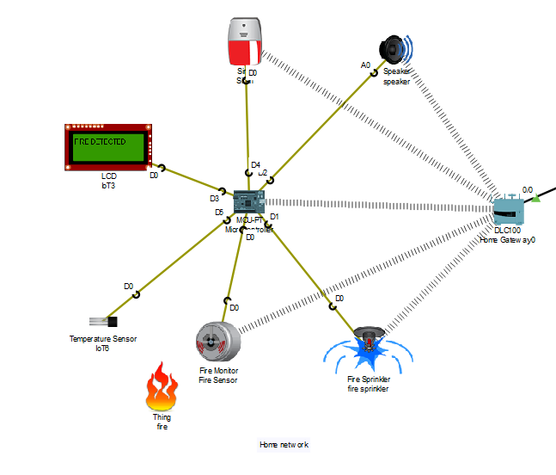

Figure: Home network.

In the home network Microcontroller will control all the devices like fire sensor, fire sprinkler, Specker, Siren and the LCD display. When the fire sensor Detects fire in the house the Microcontroller will automatically turn on fire sprinkler, Specker, Siren and in the LCD display Fire Detected message will be shown. Fire Detection information will be transfer wirelessly using home gateway device to the Remote IoT server Which will transfer the information to the user’s phone.

**IoT Server Network:**

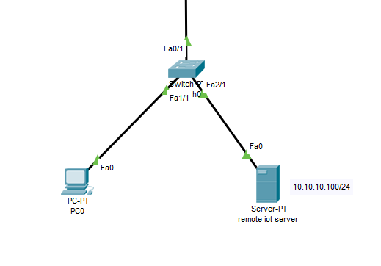

Figure: IoT server network.

When the fire sensor detects fire, Fire Detection information will be transfer wirelessly using home gateway device to the Remote IoT server Which will transfer the information to the user’s phone. Admin of the IoT server also can see the information of the sensors and also can monitor the home network.

**Mobile Access Network:**

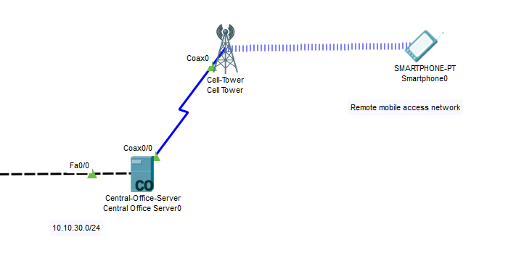

Figure: Mobile access network.

User can see the information of the sensor and condition of the home network by just logging in to the IoT monitor option by using user’s smart phone. The IoT server will send the information of home network to the user’s network and user will be able to see the condition of the sensors and also can control the devices if necessary.

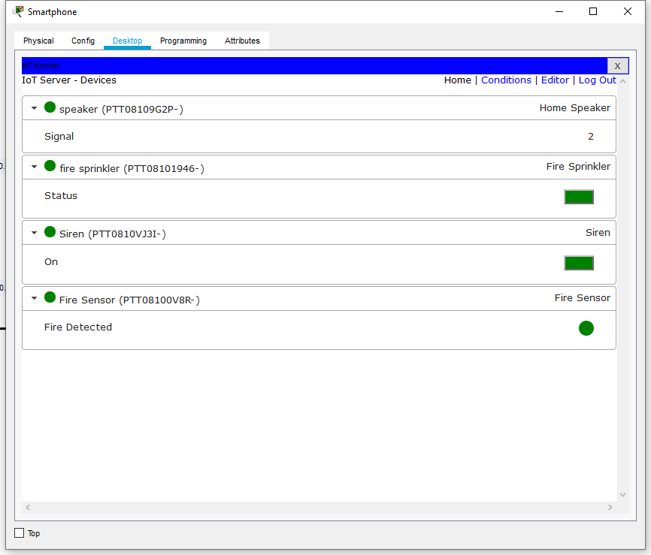

Figure: IoT monitor option for smartphone.

**The Whole Network:**

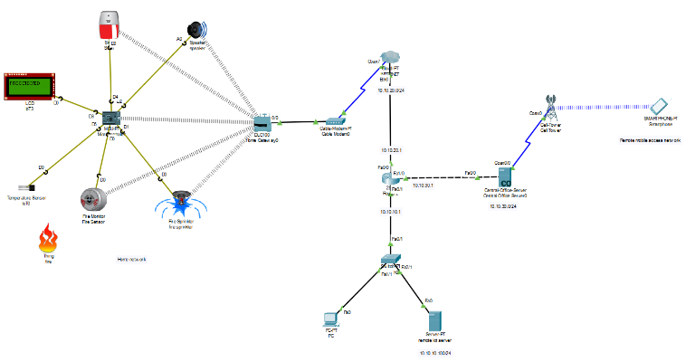

Figure: Fire alert system whole network.

# Future Work

The quantity of sensors isn't restricted and we can broaden this application utilizing more number of sensors with the help of sequential correspondence conventions like I2C, CAN, and so forth likewise, this qualities can be observed from anyplace in the world utilizing IOT innovation by interfacing our framework to the web.[3]

1. **Code**

from gpio import *

from time import *

def main():

pinMode (0,INPUT)

pinMode (1,OUT)

while True:

fire = digitalRead(0);

if(fire==1023):

customWrite(1,'1');

customWrite(3,'FIRE DETECTED');

digitalWrite(2,HIGH);

customWrite(4,HIGH);

else:

customWrite(1,'0');

customWrite(3,'SAFE');

digitalWrite(2,LOW);

customWrite(4,LOW);

if __name__ == "__main__":

main()

# Conclusion

In this theory, the point is to plan an alarm and control framework with a Minimal expense with successful use and make it more clients agreeable and simple to work. so, fire sensor and Arduino are utilized lessen the wastage of power, save lives lessen level of mishap and decrease misuse of electric apparatus. the program installed in the Arduino Nano works as per the need A bit by bit approach in planning Arduino based framework for temperature estimation has been followed. As indicated by the investigation and examination of different pieces of the framework a configuration has been completed the outcomes gotten from the estimation has shown that the framework performs well under all conditions and the endeavour has been finished.

**References:**

[1] I. Of and U. P. I. D. Controller, “Sudan University of Science and Technology College of Engineering Electrical Engineering مادختسإب ةشاشلاو ة ركلا يف مكحت ماظن ذيفنتو ميمصت يمضافتلا يمماكتلا يبسانتلا مكحتملا,” no. October, 2017.

[2] M. S. Jamri, Z. H. Bohari, M. F. Baharom, M. H. Jali, M. N. M. Nasir, and T. A. Izzuddin, “Development of Novel Fire Alarm Warning System Using Automated Remote Messaging Method,” *Applied Mechanics and Materials*, vol. 793, pp. 578–584, 2015, doi: 10.4028/www.scientific.net/amm.793.578.

[3] S. Harika, V. Srikanth, and P. Vikram, “Fire Accident Detection System in Industries,” *Indian Journal of Science and Technology*, vol. 10, no. 4, pp. 1–5, 2017, doi: 10.17485/ijst/2017/v10i4/110670.